Spread Adjust for GNMA Current Coupon

- Data Problem in Building GNMA Coupon Curve

We find the GNMA TBA data during August 2010 and December 2010 shows a poor condition. It is difficult to get a reasonable coupon value based on that data set; even we use our extrapolation method.
Take 2010-10-15 as an example, based on the algorithm, we choose to use Sep and Oct settlement data. And we choose coupon base on the front month (Sep) data.
 | Sep | Oct | Nov | Dec
3 | 100.2813 | 99.96875 | 99.64063 | 99.3125
3.5 | 100.3281 | 100.0156 | 99.6875 | 99.35938

Obviously, all the settlement prices are higher than 100. So we need to do the vertical extrapolation based on the nearest coupon data, to find the near par coupon. Shaded areas are extrapolated data points.
 | Sep | Oct | Nov | Dec
0 | 100 | 99.6875
0.5 | 100.0469 | 99.73438
1 | 100.0938 | 99.78125
1.5 | 100.1406 | 99.82813
2 | 100.1875 | 99.875
2.5 | 100.2344 | 99.92188
3 | 100.2813 | 99.96875 | 99.64063 | 99.3125
3.5 | 100.3281 | 100.0156 | 99.6875 | 99.35938

Using our equal step extrapolation method, we need to do 6 times extrapolation to get a price close to par. That makes our calculation result drop sharply at that date. Result shows as below:
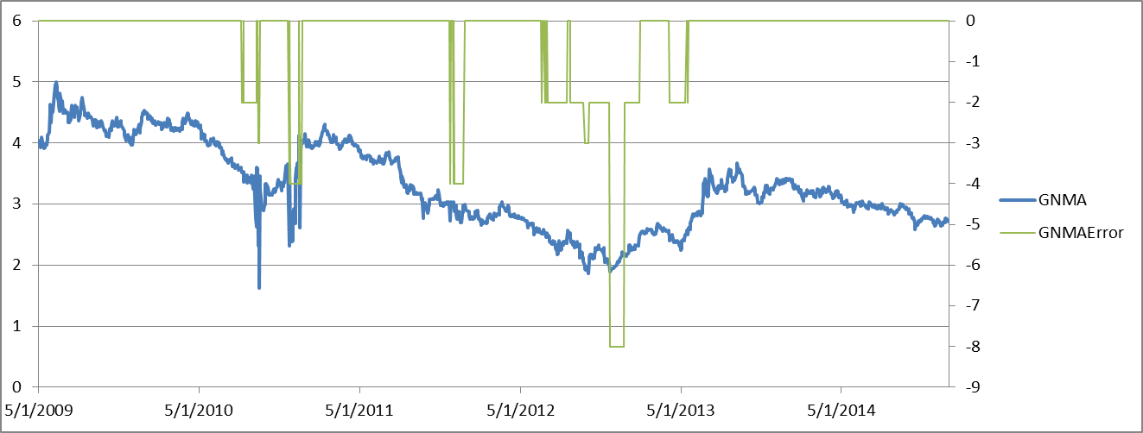

Blue line is the coupon calculation result. Green line shows the error type refer to the table below:
Error Code | Description
-1 | no data for that day
-2 | Prices all higher/lower than par! single extrapolation
-3 | Multiple times extrapolation
-4 | No error on front month. but missing data for back month
-5 | not enough data for back month Horizontal interpolation
-6 | Lower coupon with higher price
-7 | Same price for the two coupons
-8 | After extrapolation, still not enough data for back month

An easier way to understand the chart is, when the green line drops, there is something wrong with the data, and we need to do extrapolation at that day. We can see around one fifth of the TBA data has some kind of problem. However, the results remain reasonable for most of cases after extrapolation. The only issue occurs during 2010.

- Exam the GNMAII data and GNMA spread

In order to modify the GNMA data for 2010, we checked the GNMAII data. So we can have a sense whether it is feasible to optimize GNMA coupon with GNMAII data.
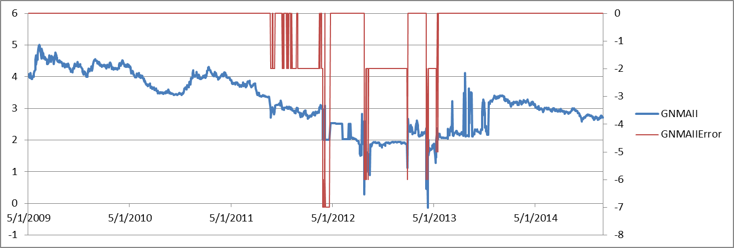

Similarly, blue line in this chart shows GNMAII coupon rate, while red line shows the data error type. Although the error tag shows a very low quality of data during 2012 and 2013, the GNMAII data before 2012 is actually quite good. So there is a possibility that using GNMAII data to enhance the result of GNMA coupon model.

The way we connect this to rate together is to use a spread between them to get a adjust rate:
$$Adjust Rate= \overline{GNMA Coupon-GNMAII Coupon}$$
Using data from May 2009 to July 2010, we get a adjust rate of -3.52 bps.

- Update GNMA Coupon Model by GNMAII Spread

After having the adjust rate, we can update the GNMA Coupon Model. As we can find from the first chart, not every data point in GNMA during August to December 2010 has problem. So it is not reasonable to modify every point, in other word, we need a tolerance for the daily spread.
$$daily spread=daily GNMA coupon-daily GNMAII coupon$$

Assume that we have a tolerance equal to 10 bps, the updated GNMA coupon will be:
$$if GNMA-GNMAII<tolerance \\ Then, updated GNMA=GNMA; \\ else, updated GNMA=GNMAII+Adjust Rate$$
In that way, we keep the original calculation which has a difference with GNMAII smaller 10 bps. The assumption behind this adjustment is high quality data set for GNMAII as showed in chart 2 before 2012.
After adjustment, the GNMA current coupon result is showed below:

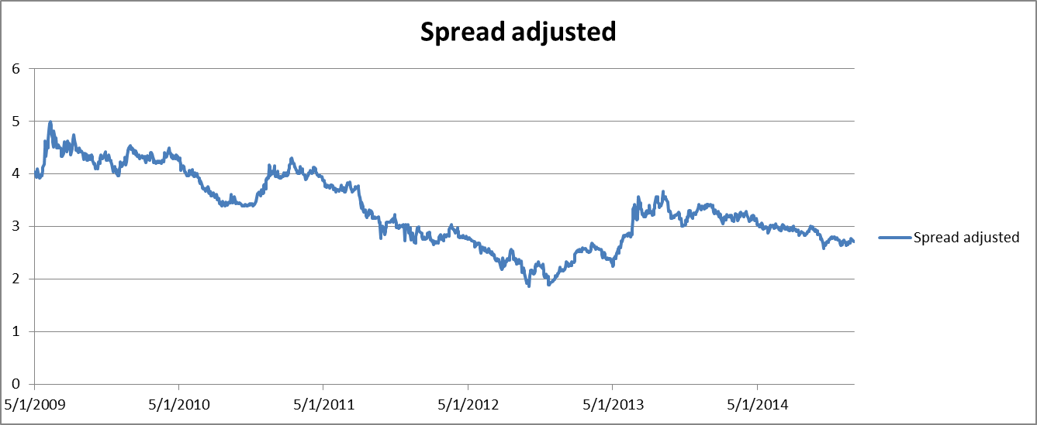

Comparing with Chart 1, the spread adjusted result has a much better performance in 2010.

